1.**Web checkin Process**

* **A.** Process starts 48hours before the flyte taking time   
   In ticket if it is mentioned as 6.45 am flight take off time , then web checkin can be done 48 hours before that time.
* **B. For check-in reference number**

**Use the PNR number (6 digit) in ticker but not the booking reference number of the ticket**

Ticket:

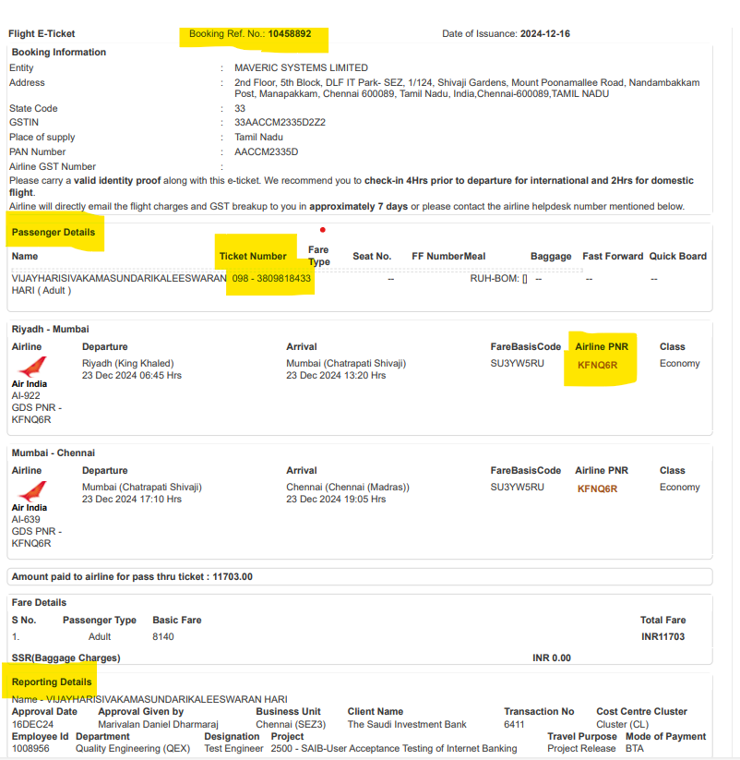

**Screen01:**

**Screen02:**

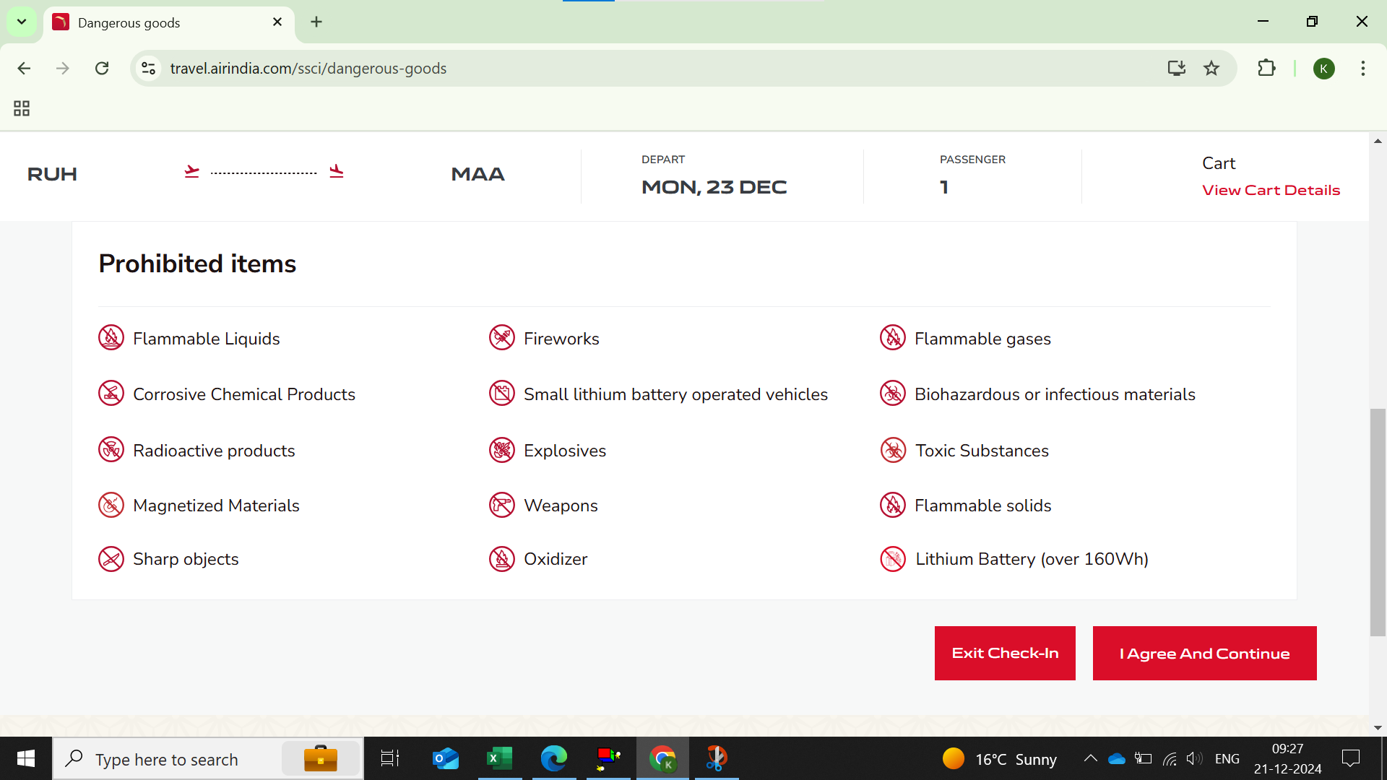

**Screen03: Seat Reservation  
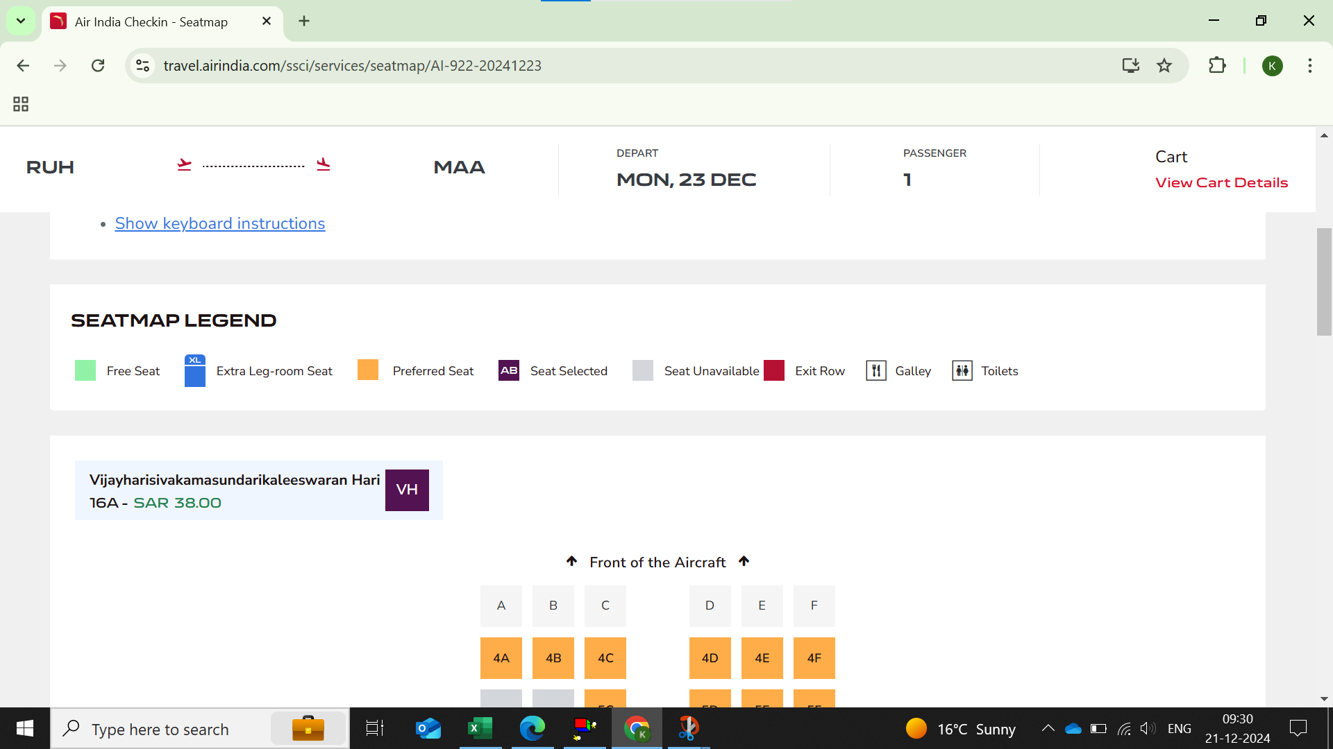**

**Screen04:**

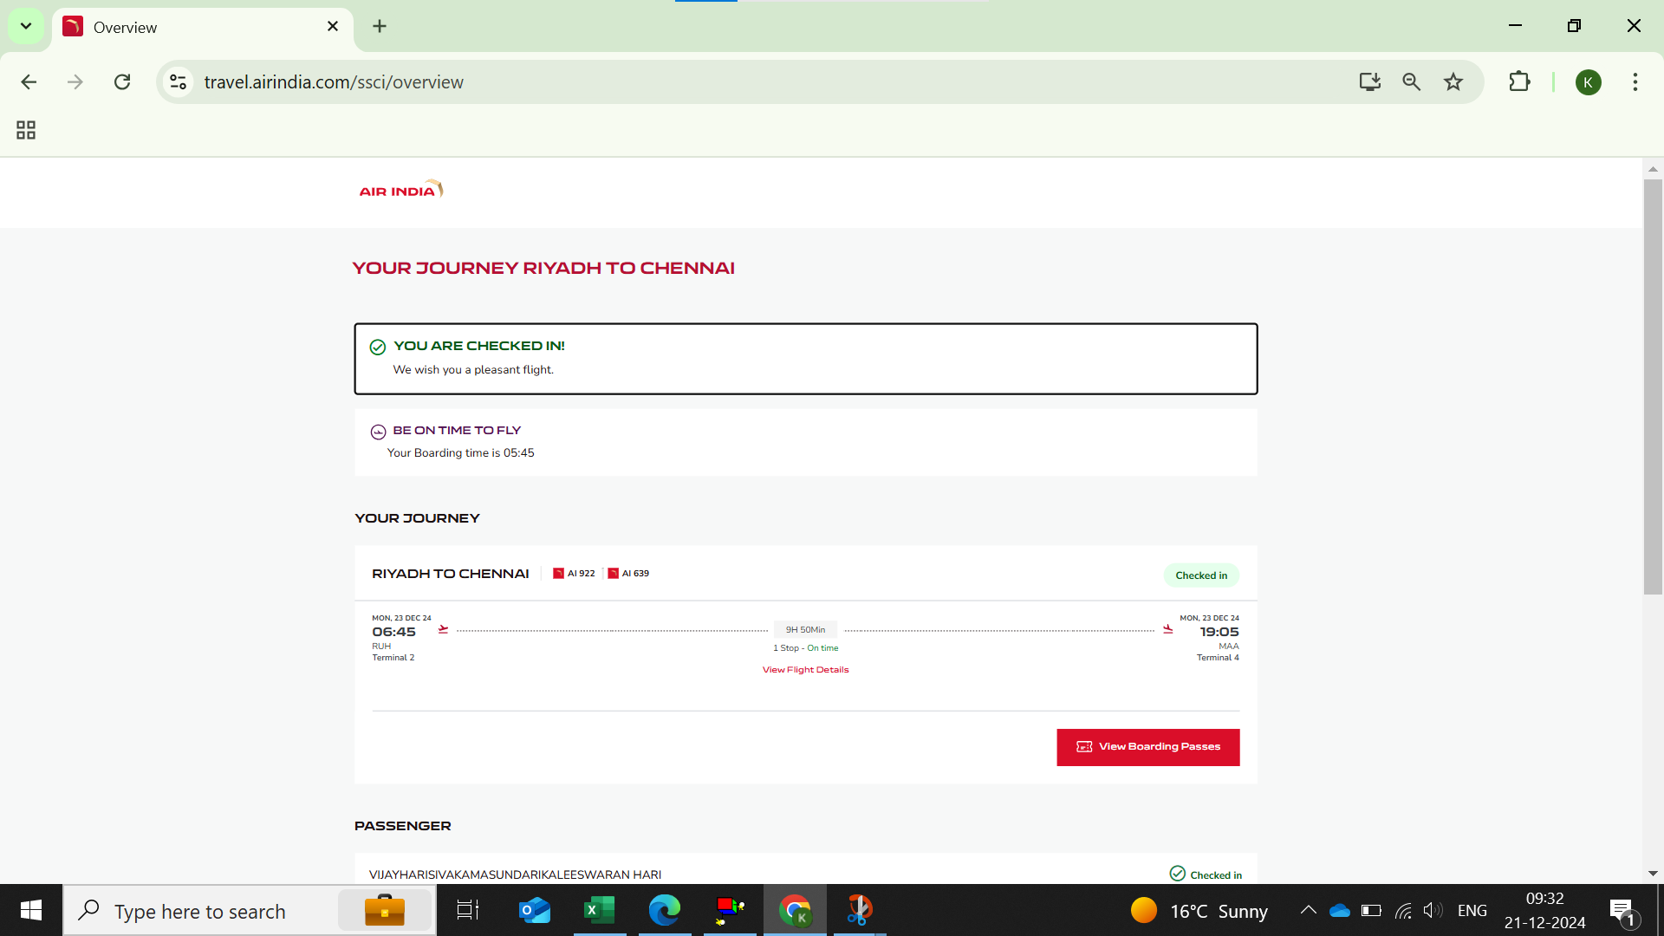

**Screen 05:s**

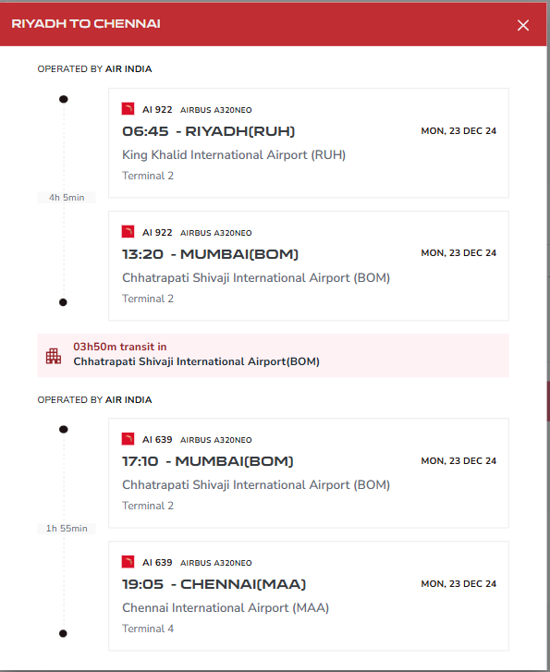

**C.Boarding Pass will be generated after web check in :**

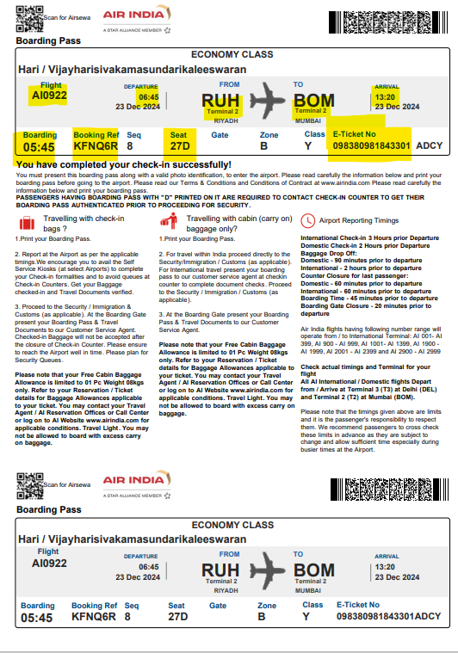

**D.Insurance Copy**

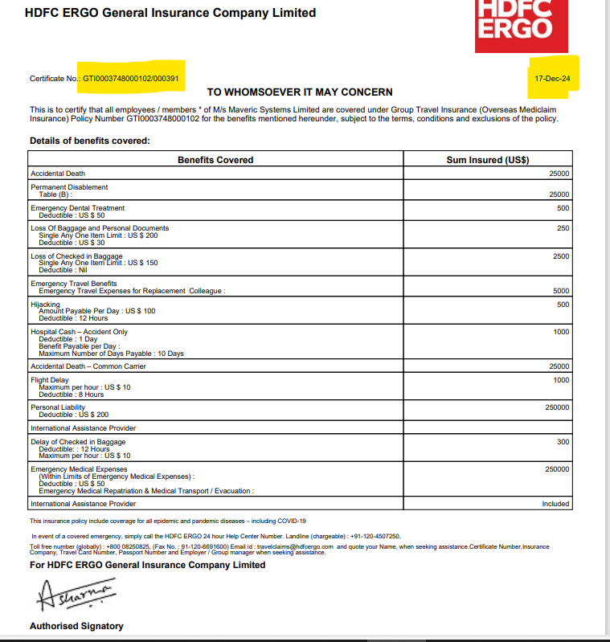**s**

